Project Design Phase-I
Solution Architecture

Date | 26 July 2025
Team ID | PNT2025TMID08395
Project Name | Visualizing Housing Market Trends: An Analysis of Sale Prices and Features using Tableau
Maximum Marks | 4 Marks

Solution Architecture:
Solution architecture is a complex process – with many sub-processes – that bridges the gap between business problems and technology solutions. Its goals are to:
- Provide an end-to-end platform that ingests housing data, cleans & enriches it.
- It stores for analytics, and exposes interactive Tableau dashboards so stakeholders can explore sales, renovation impact, house-age and feature patterns.

Example - Solution Architecture Diagram:

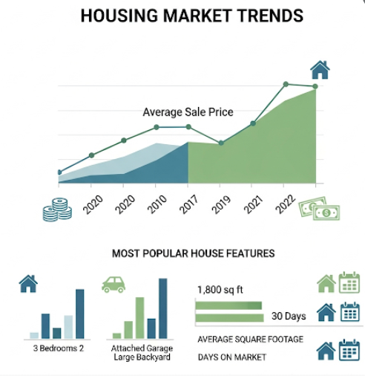
Figure 1: Architecture and data flow of the voice patient diary sample application
Reference: https://aws.amazon.com/blogs/industries/voice-applications-in-clinical-research-powered-by-ai-on-aws-part-1-architecture-and-design-considerations/

